Write a program in C to implement the Optimal Page Replacement Algorithm.
Source Code:
#include <stdio.h>
int main() {
int n, pg[30], fr[10];
int count[10], i, j, k, fault, f, flag, temp, current, c, dist, max, m, cnt, p, x;
fault = 0;
dist = 0;
k = 0;
printf("Enter the total number of pages: ");
scanf("%d", &n);
printf("Enter the page reference sequence: ");
for (i = 0; i < n; i++)
scanf("%d", &pg[i]);
printf("Enter frame size: ");
scanf("%d", &f);
for (i = 0; i < f; i++) {
count[i] = 0;
fr[i] = -1;
}
printf("\nPage\tFrames\n");
for (i = 0; i < n; i++) {
flag = 0;
temp = pg[i];
for (j = 0; j < f; j++) {
if (temp == fr[j]) {
flag = 1;
break;
}
}
if ((flag == 0) && (k < f)) {
fault++;
fr[k] = temp;
k++;
} else if ((flag == 0) && (k == f)) {
fault++;
for (cnt = 0; cnt < f; cnt++) {
current = fr[cnt];
for (c = i; c < n; c++) {
if (current != pg[c])
count[cnt]++;
else
break;
}
}
max = 0;
for (m = 0; m < f; m++) {
if (count[m] > max) {
max = count[m];
p = m;
}
}
fr[p] = temp;
}
printf("%d\t\t", pg[i]);
for (x = 0; x < f; x++) {
printf("%d\t\t", fr[x]);
}
printf("\n");
}
printf("\nTotal number of page faults: %d\n", fault);
printf("\nName: ASHESH NEUPANE \t T.U. Exam Roll No: 16295 / 23");
return 0;
}

Output Screen:

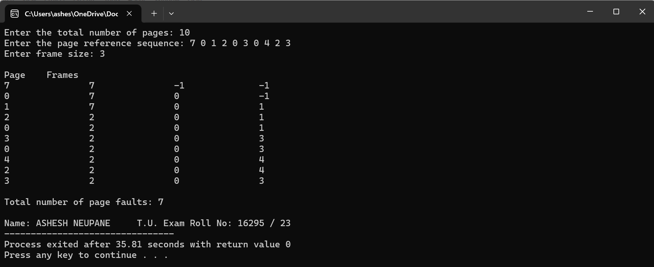

Write a C Program to implement the Round Robin (RR) CPU Scheduling Algorithm with arrival time.
Source Code:
#include <stdio.h>
int main() {
int i, processes, sum = 0, cnt = 0, y, q, wt = 0, tat = 0, at[10], bt[10], temp[10];
float avg_waitt, avg_turnat;
// Input the number of processes
printf("Total number of processes in the system: ");
scanf("%d", &processes);
y = processes; // Assign number of processes to y
// Input arrival time and burst time for each process
for(i = 0; i < processes; i++) {
printf("\nEnter the Arrival and Burst time of Process[%d]\n", i + 1);
printf("Arrival time: ");
scanf("%d", &at[i]);
printf("Burst time: ");
scanf("%d", &bt[i]);
temp[i] = bt[i]; // Initialize remaining burst time
}
// Input the time quantum
printf("Enter the Time Quantum: ");
scanf("%d", &q);
// Display header for the process info
printf("\nProcess No \tBurst Time \tTAT \t\tWaiting Time\n");
// Scheduling loop
for(sum = 0, i = 0; y != 0;) {
if(temp[i] <= q && temp[i] > 0) {
sum = sum + temp[i];
temp[i] = 0;
cnt = 1;
} else if(temp[i] > 0) {
temp[i] = temp[i] - q;
sum = sum + q;
}
if(temp[i] == 0 && cnt == 1) {
y--; // Decrement remaining processes
printf("\nProcess No[%d] \t%d \t\t%d \t\t%d", i + 1, bt[i], sum - at[i], sum - at[i] - bt[i]);
wt = wt + sum - at[i] - bt[i]; // Calculate waiting time
tat = tat + sum - at[i]; // Calculate turnaround time
cnt = 0;
}
if(i == processes - 1) {
i = 0;
} else if(at[i + 1] <= sum) {
i++;
} else {
i = 0;
}
}
// Calculate average waiting time and turnaround time
avg_waitt = wt * 1.0 / processes;
avg_turnat = tat * 1.0 / processes;
printf("\nAverage Turnaround Time: %f", avg_turnat);
printf("\nAverage Waiting Time: %f", avg_waitt);
printf("\nName: ASHESH NEUPANE \t T.U. Exam Roll No: 16295 / 23");
}

Output Screen:
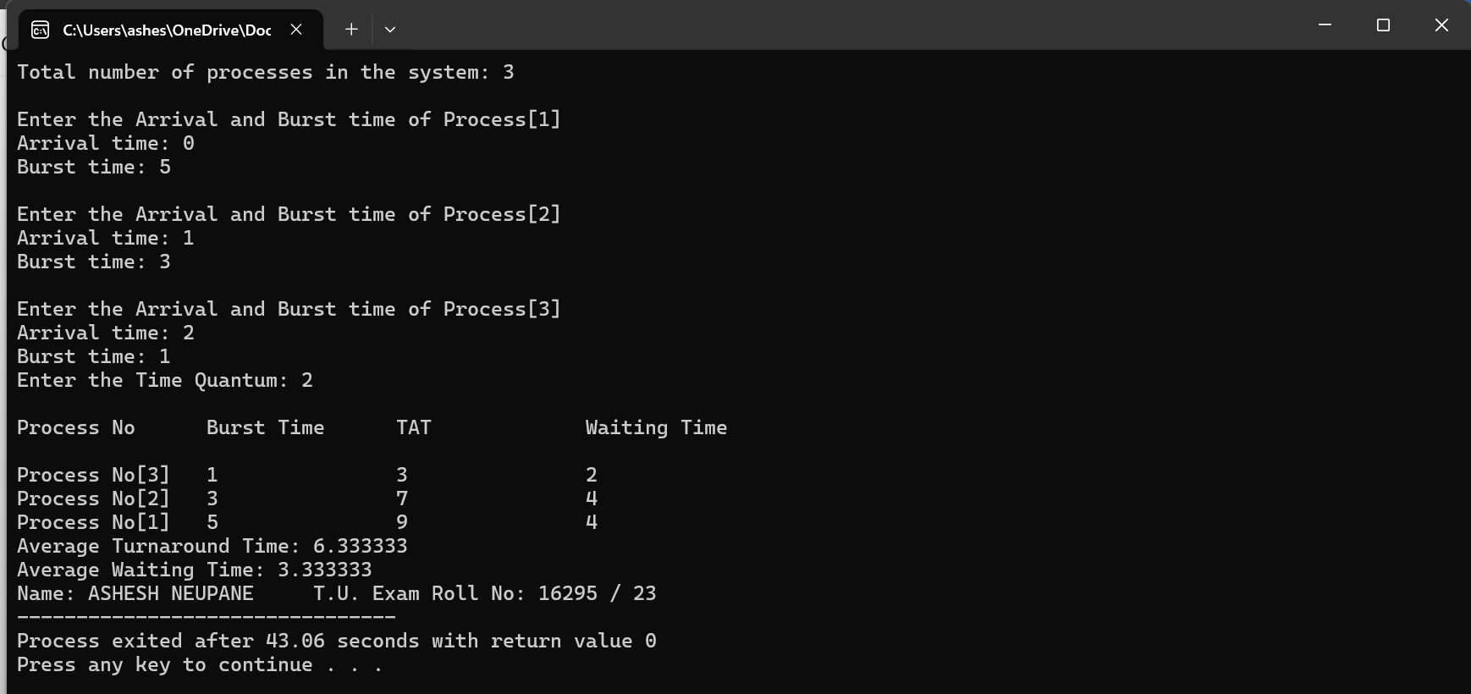

Write a C Program to implement the Least Recently Used (LRU) page replacement algorithm.
Source Code:
#include<stdio.h>
int findLRU(int time[], int n){
int i, minimum = time[0], pos = 0;
for(i = 1; i < n; ++i){
if(time[i] < minimum){
minimum = time[i];
pos = i;
}
}
return pos;
}
int main()
{
int no_of_frames, no_of_pages, frames[10], pages[30], counter = 0, time[10], flag1, flag2, i, j, pos, faults = 0;
printf("Enter number of frames: ");
scanf("%d", &no_of_frames);
printf("Enter number of pages: ");
scanf("%d", &no_of_pages);
printf("Enter reference string: ");
for(i = 0; i < no_of_pages; ++i){
scanf("%d", &pages[i]);
}
for(i = 0; i < no_of_frames; ++i){
frames[i] = -1;
}
for(i = 0; i < no_of_pages; ++i){
flag1 = flag2 = 0;
for(j = 0; j < no_of_frames; ++j){
if(frames[j] == pages[i]){
counter++;
time[j] = counter;
flag1 = flag2 = 1;
break;
}
}
if(flag1 == 0){
for(j = 0; j < no_of_frames; ++j){
if(frames[j] == -1){
counter++;
faults++;
frames[j] = pages[i];
time[j] = counter;
flag2 = 1;
break;
}
}
}
if(flag2 == 0){
pos = findLRU(time, no_of_frames);
counter++;
faults++;
frames[pos] = pages[i];
time[pos] = counter;
}
printf("\n");
for(j = 0; j < no_of_frames; ++j){
printf("%d\t", frames[j]);
}
}
printf("\n\nTotal Page Faults = %d", faults);
printf("\nName: ASHESH NEUPANE \t T.U. Exam Roll No: 16295 / 23");
return 0;
}

Output Screen:
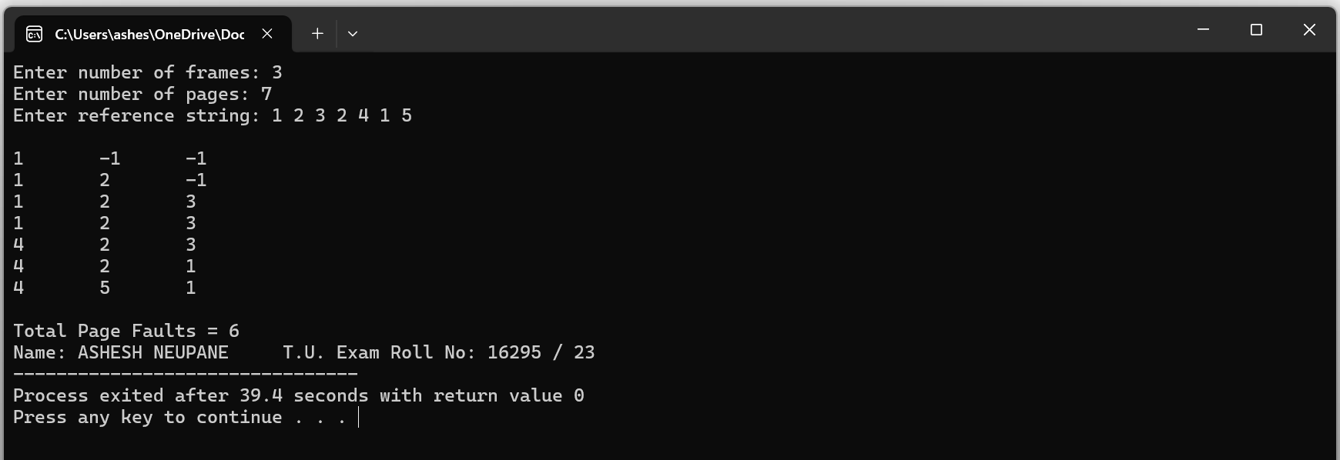

Write a program in C to implement the Worst Fit memory allocation strategy.
Source Code:
#include <stdio.h>
void implementWorstFit(int blockSize[],int blocks,int processSize[],int processes)
{
int allocation[processes];
for(int i=0;i<processes;i++)allocation[i]=-1;
for(int i=0;i<processes;i++){
int indexPlaced=-1;
for(int j=0;j<blocks;j++){
if(blockSize[j]>=processSize[i]){
if(indexPlaced==-1)indexPlaced=j;
else if(blockSize[indexPlaced]<blockSize[j])indexPlaced=j;
}
}
if(indexPlaced!=-1){
allocation[i]=indexPlaced;
blockSize[indexPlaced]-=processSize[i];
}
}
printf("\nProcess No.\tProcess Size\tBlock No.\n");
for(int i=0;i<processes;i++){
printf("%d\t\t%d\t\t",i+1,processSize[i]);
if(allocation[i]!=-1)printf("%d\n",allocation[i]+1);
else printf("Not Allocated\n");
}
}
int main()
{
int blockSize[]={500,100,60};
int processSize[]={50,80,100};
int blocks=sizeof(blockSize)/sizeof(blockSize[0]);
int processes=sizeof(processSize)/sizeof(processSize[0]);
implementWorstFit(blockSize,blocks,processSize,processes);
printf("\nName: ASHESH NEUPANE \t T.U. Exam Roll No: 16295 / 23");
return 0;
}

Output Screen:
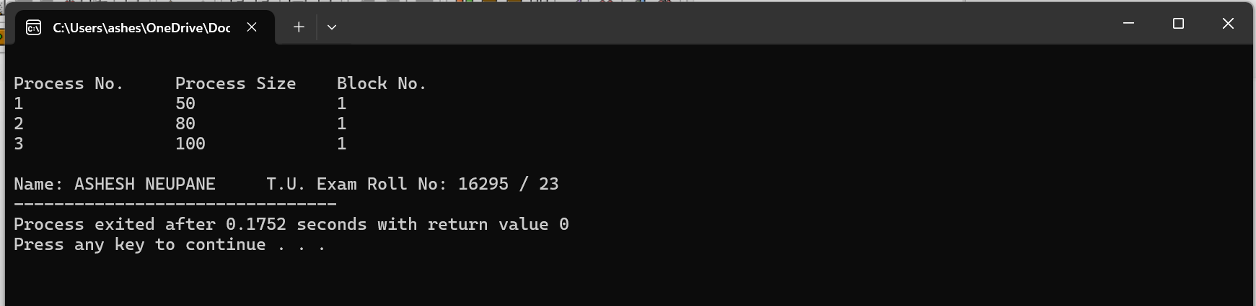

Write a program in C to implement Non-Preemptive Priority Scheduling.
Source Code:
#include <stdio.h>
void swap(int *a,int *b)
{
int temp=*a;
*a=*b;
*b=temp;
}
int main()
{
int n;
printf("Enter Number of Processes: ");
scanf("%d",&n);
int burst[n],priority[n],index[n];
for(int i=0;i<n;i++)
{
printf("Enter Burst Time and Priority Value for Process %d: ",i+1);
scanf("%d %d",&burst[i],&priority[i]);
index[i]=i+1;
}
for(int i=0;i<n;i++)
{
int temp=priority[i],m=i;
for(int j=i;j<n;j++)
{
if(priority[j]>temp)
{
temp=priority[j];
m=j;
}
}
swap(&priority[i],&priority[m]);
swap(&burst[i],&burst[m]);
swap(&index[i],&index[m]);
}
int t=0;
printf("Order of process Execution is\n");
for(int i=0;i<n;i++)
{
printf("P%d is executed from %d to %d\n",index[i],t,t+burst[i]);
t+=burst[i];
}
printf("\n");
printf("Process Id\tBurst Time\tWait Time\tTurnaround Time\n");
int wait_time=0;
int total_wait_time=0;
int total_turnaround=0;
for(int i=0;i<n;i++)
{
int turnaround=wait_time+burst[i];
printf("P%d\t\t%d\t\t%d\t\t%d\n",index[i],burst[i],wait_time,turnaround);
total_wait_time+=wait_time;
total_turnaround+=turnaround;
wait_time+=burst[i];
}
float avg_wait_time=(float)total_wait_time/n;
float avg_turnaround=(float)total_turnaround/n;
printf("Average waiting time is %f\n",avg_wait_time);
printf("Average TurnAround Time is %f\n",avg_turnaround);
printf("\nName: ASHESH NEUPANE \t T.U. Exam Roll No: 16295 / 23");
return 0;
}

Output Screen:

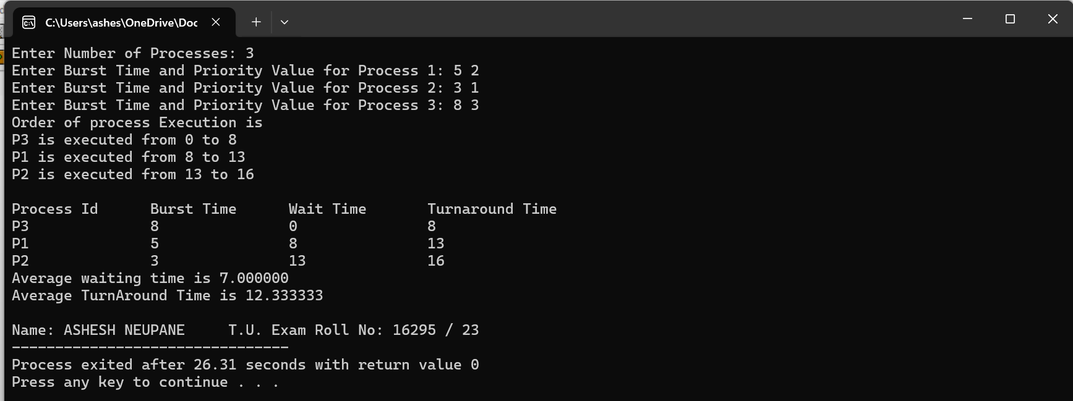

Write a program in C to implement the Shortest Seek Time First (SSTF) disk scheduling algorithm.
Source Code:
#include <stdio.h>
#include <stdlib.h>
int main() {
int RQ[100], visited[100], n, i, initial, TotalHeadMovement = 0, count = 0;
printf("Enter the number of Requests\n");
scanf("%d", &n);
printf("Enter the Requests sequence\n");
for(i = 0; i < n; i++) {
scanf("%d", &RQ[i]);
visited[i] = 0; // initialize visited array
}
printf("Enter initial head position\n");
scanf("%d", &initial);
printf("Disk Service Sequence: ");
while(count != n) {
int min = 1000000, index = -1;
for(i = 0; i < n; i++) {
if(!visited[i]) {
int distance = abs(RQ[i] - initial);
if(distance < min) {
min = distance;
index = i;
}
}
}
visited[index] = 1; // mark as visited
TotalHeadMovement += min;
printf("%d -> ", RQ[index]);
initial = RQ[index];
count++;
}
printf("End\n");
printf("Total head movement is %d\n", TotalHeadMovement);
printf("\nName: ASHESH NEUPANE \t T.U. Exam Roll No: 16295 / 23");
return 0;
}

Output Screen:
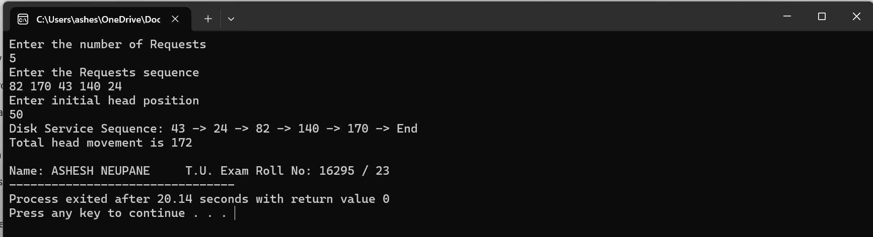

Write a program in C to implement the FIFO Page Replacement Algorithm.
Source Code:
#include <stdio.h>
void fifo(int ref[20], int reflen, int fnum) {
int i, j, k, firstin = 0, found, phit = 0, pfault = 0;
int frame[10];
for(j = 0; j < fnum; j++)
frame[j] = -1;
printf("\nPage Trace:\n");
for(i = 0; i < reflen; i++) {
found = 0;
for(j = 0; j < fnum; j++) {
if(ref[i] == frame[j]) {
found = 1;
phit++;
break;
}
}
if(found == 0) {
pfault++;
frame[firstin] = ref[i];
firstin = (firstin + 1) % fnum;
}
for(k = 0; k < fnum; k++) {
if(frame[k] != -1)
printf("%d\t", frame[k]);
}
printf("\n");
}
printf("\nPage Hits: %d\nPage Faults: %d\n", phit, pfault);
}
int main() {
int i, reflen, fnum, refstr[20];
printf("Enter reference string length & number of frames: ");
scanf("%d %d", &reflen, &fnum);
printf("Enter pages of reference string: ");
for(i = 0; i < reflen; i++)
scanf("%d", &refstr[i]);
fifo(refstr, reflen, fnum);
printf("\nName: ASHESH NEUPANE \t T.U. Exam Roll No: 16295 / 23");
return 0;
}

Output Screen:
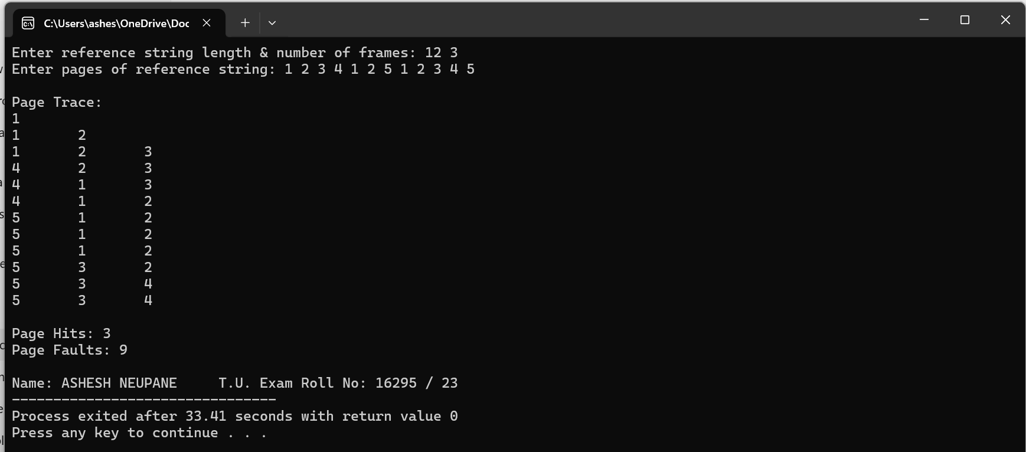

Write a program in C to implement the First-Come, First-Served (FCFS) Scheduling Algorithm.
Source Code:
#include <stdio.h>
struct Process {
int pid; // Process ID
int arrival_time; // Arrival time
int burst_time; // Burst time
int completion_time; // Completion time
int waiting_time; // Waiting time
int turnaround_time; // Turnaround time
};
void findCompletionTime(struct Process proc[], int n) {
int current_time = 0;
for (int i = 0; i < n; i++) {
if (current_time < proc[i].arrival_time) {
current_time = proc[i].arrival_time;
}
current_time += proc[i].burst_time;
proc[i].completion_time = current_time;
}
}
void findTurnaroundTime(struct Process proc[], int n) {
for (int i = 0; i < n; i++) {
proc[i].turnaround_time = proc[i].completion_time - proc[i].arrival_time;
}
}
void findWaitingTime(struct Process proc[], int n) {
for (int i = 0; i < n; i++) {
proc[i].waiting_time = proc[i].turnaround_time - proc[i].burst_time;
}
}
void printProcessTable(struct Process proc[], int n) {
printf("PID\t\t Arrival Time \t\tBurst Time \t\tCompletion Time\t\tTurnaround Time \t\t Waiting Time \n");
for (int i = 0; i < n; i++) {
printf("%d\t\t %d\t\t%d\t\t%d\t\t%d\t\t%d\n",
proc[i].pid, proc[i].arrival_time, proc[i].burst_time,
proc[i].completion_time, proc[i].turnaround_time, proc[i].waiting_time);
}
}
int main() {
int n;
printf("Enter the number of processes: ");
scanf("%d", &n);
struct Process proc[n];
for (int i = 0; i < n; i++) {
printf("Enter arrival time and burst time for process %d: ", i + 1);
proc[i].pid = i + 1;
scanf("%d%d", &proc[i].arrival_time, &proc[i].burst_time);
}
// Sort processes by arrival time
for (int i = 0; i < n - 1; i++) {
for (int j = 0; j < n - i - 1; j++) {
if (proc[j].arrival_time > proc[j + 1].arrival_time) {
struct Process temp = proc[j];
proc[j] = proc[j + 1];
proc[j + 1] = temp;
}
}
}
findCompletionTime(proc, n);
findTurnaroundTime(proc, n);
findWaitingTime(proc, n);
printProcessTable(proc, n);
printf("\nName: ASHESH NEUPANE \t T.U. Exam Roll No: 16295 / 23");
return 0;
}

Output Screen:
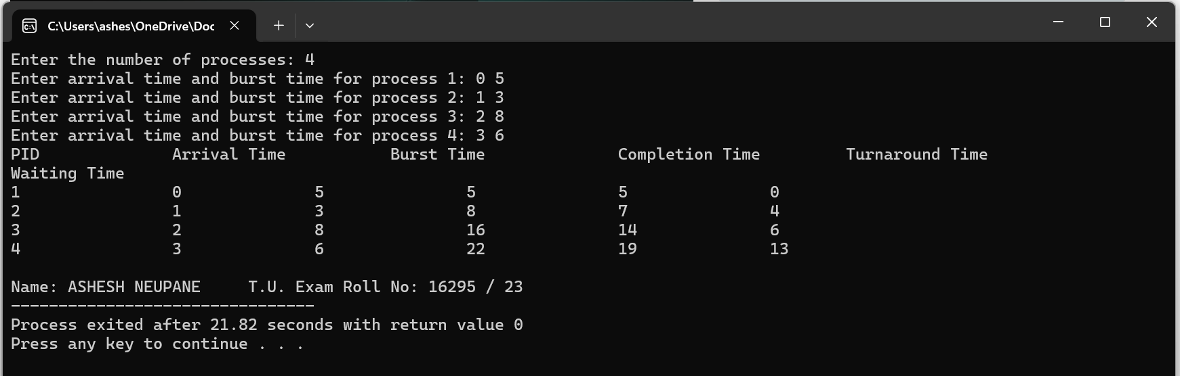

Write a program in C to implement the C-SCAN (Circular SCAN) Disk Scheduling Algorithm.
Source Code:
#include <stdio.h>
#include <stdlib.h>
int main() {
int n, head, max, seek = 0;
printf("Enter the maximum range of the disk: ");
scanf("%d", &max);
printf("Enter the initial head position: ");
scanf("%d", &head);
printf("Enter the number of requests: ");
scanf("%d", &n);
int requests[n], queue1[n], queue2[n];
int temp1 = 0, temp2 = 0;
printf("Enter the disk request queue: ");
for (int i = 0; i < n; i++) {
scanf("%d", &requests[i]);
if (requests[i] >= head)
queue1[temp1++] = requests[i];
else
queue2[temp2++] = requests[i];
}
// Sort queue1 and queue2 in ascending order
for (int i = 0; i < temp1 - 1; i++) {
for (int j = i + 1; j < temp1; j++) {
if (queue1[i] > queue1[j]) {
int temp = queue1[i];
queue1[i] = queue1[j];
queue1[j] = temp;
}
}
}
for (int i = 0; i < temp2 - 1; i++) {
for (int j = i + 1; j < temp2; j++) {
if (queue2[i] > queue2[j]) {
int temp = queue2[i];
queue2[i] = queue2[j];
queue2[j] = temp;
}
}
}
int total_requests = temp1 + temp2 + 2; // including max and 0
int sequence[total_requests];
int index = 0;
sequence[index++] = head;
// Add requests greater than or equal to head
for (int i = 0; i < temp1; i++)
sequence[index++] = queue1[i];
sequence[index++] = max; // move to end
sequence[index++] = 0; // jump to start
// Add remaining requests
for (int i = 0; i < temp2; i++)
sequence[index++] = queue2[i];
printf("Disk Service Sequence: ");
for (int i = 0; i < total_requests - 1; i++) {
int diff = abs(sequence[i + 1] - sequence[i]);
seek += diff;
printf("%d -> ", sequence[i]);
}
printf("%d\n", sequence[total_requests - 1]);
printf("Total seek time: %d\n", seek);
printf("Average seek time: %.2f\n", (float)seek / n);
printf("\nName: ASHESH NEUPANE \t T.U. Exam Roll No: 16295 / 23");
return 0;
}

Output Screen:

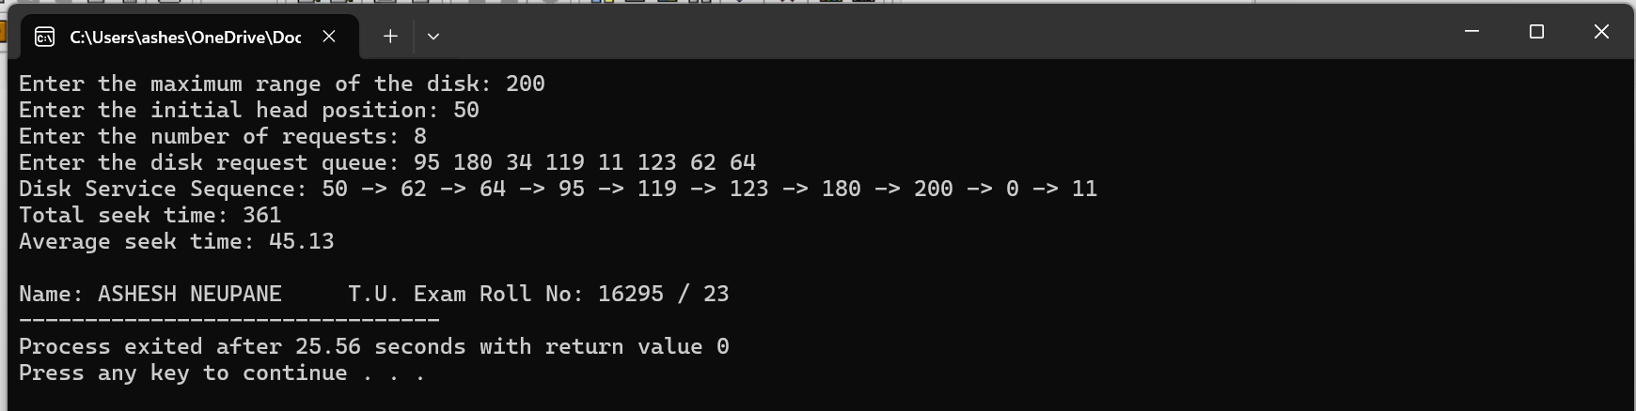

Write a program in C to implement the LOOK Disk Scheduling Algorithm.
Source Code:
#include<stdio.h>
#include<stdlib.h>
int main() {
int RQ[100], i, j, n, TotalHeadMoment = 0, initial, size;
printf("Enter the number of Requests\n");
scanf("%d", &n);
printf("Enter the Requests sequence\n");
for (i = 0; i < n; i++)
scanf("%d", &RQ[i]);
printf("Enter initial head position\n");
scanf("%d", &initial);
printf("Enter total disk size\n");
scanf("%d", &size);
// Sort the request array
for (i = 0; i < n; i++)
for (j = 0; j < n - i - 1; j++)
if (RQ[j] > RQ[j + 1]) {
int temp = RQ[j];
RQ[j] = RQ[j + 1];
RQ[j + 1] = temp;
}
// Find the index of initial head position
int index;
for (i = 0; i < n; i++) {
if (initial < RQ[i]) {
index = i;
break;
}
}
printf("Disk Movement Sequence: ");
// Calculate total head movement and show disk movement sequence
for (i = index; i < n; i++) {
printf("%d -> ", initial);
TotalHeadMoment += abs(RQ[i] - initial);
initial = RQ[i];
}
for (i = index - 1; i >= 0; i--) {
printf("%d -> ", initial);
TotalHeadMoment += abs(RQ[i] - initial);
initial = RQ[i];
}
printf("%d\n", initial); // Print the last disk process
printf("Total head movement is %d", TotalHeadMoment);
printf("\nName: ASHESH NEUPANE \t T.U. Exam Roll No: 16295 / 23");
return 0;
}

Output Screen:
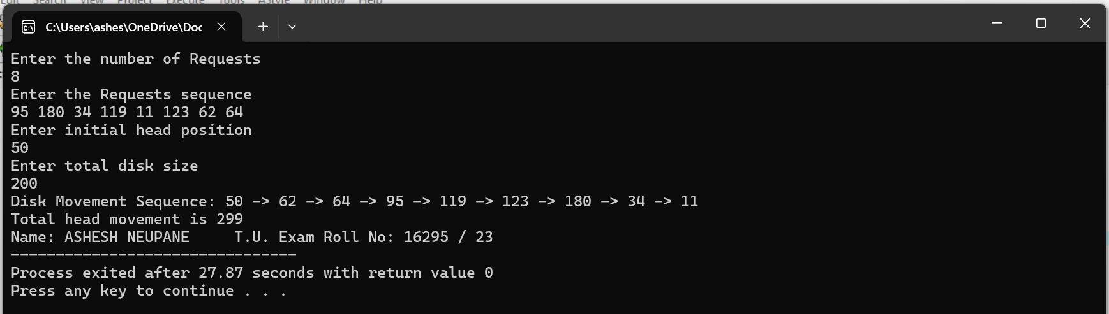

Write a program in C to implement the SCAN Disk Scheduling Algorithm.
Source Code:
#include <stdio.h>
#include <stdlib.h>
int comp(const void *a, const void *b) {
return (*(int*)a - *(int*)b);
}
void SCAN(int arr[], int n, int head, int disk_size, char direction) {
int left[100], right[100];
int seek_sequence[200];
int seek_count = 0, index = 0;
int lsize = 0, rsize = 0;
// add requests to left and right
for (int i = 0; i < n; i++) {
if (arr[i] < head)
left[lsize++] = arr[i];
else
right[rsize++] = arr[i];
}
// add 0 or disk end depending on direction
if (direction == 'l')
left[lsize++] = 0;
else if (direction == 'r')
right[rsize++] = disk_size - 1;
// sort both sides
qsort(left, lsize, sizeof(int), comp);
qsort(right, rsize, sizeof(int), comp);
// move in SCAN direction
int run = 2; // two runs: initial direction + reverse
while (run--) {
if (direction == 'l') {
for (int i = lsize - 1; i >= 0; i--) {
seek_sequence[index++] = left[i];
seek_count += abs(head - left[i]);
head = left[i];
}
direction = 'r';
} else if (direction == 'r') {
for (int i = 0; i < rsize; i++) {
seek_sequence[index++] = right[i];
seek_count += abs(head - right[i]);
head = right[i];
}
direction = 'l';
}
}
printf("Total head movement = %d\n", seek_count);
printf("Seek Sequence: ");
for (int i = 0; i < index; i++) {
printf("%d", seek_sequence[i]);
if (i != index - 1) printf(" -> ");
}
printf("\n");
}
int main() {
int n, head, disk_size;
char direction;
printf("Enter total disk size: ");
scanf("%d", &disk_size);
printf("Enter number of requests: ");
scanf("%d", &n);
int arr[n];
printf("Enter the request sequence: ");
for (int i = 0; i < n; i++)
scanf("%d", &arr[i]);
printf("Enter initial head position: ");
scanf("%d", &head);
printf("Enter direction (l for left, r for right): ");
scanf(" %c", &direction);
SCAN(arr, n, head, disk_size, direction);
printf("\nName: ASHESH NEUPANE \t T.U. Exam Roll No: 16295 / 23");
return 0;
}

Output Screen:
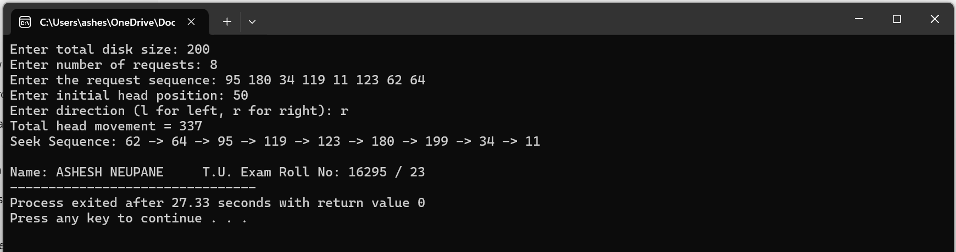

Write a program in C to implement the Best Fit Memory Allocation Algorithm.
Source Code:
#include <stdio.h>
void implimentBestFit(int blockSize[], int blocks, int processSize[], int proccesses)
{
int allocation[proccesses];
int occupied[blocks];
for(int i = 0; i < proccesses; i++){
allocation[i] = -1;
}
for(int i = 0; i < blocks; i++){
occupied[i] = 0;
}
for (int i = 0; i < proccesses; i++)
{
int indexPlaced = -1;
for (int j = 0; j < blocks; j++) {
if (blockSize[j] >= processSize[i] && !occupied[j])
{
// place it at the first block fit to accomodate process
if (indexPlaced == -1)
indexPlaced = j;
else if (blockSize[j] < blockSize[indexPlaced])
indexPlaced = j;
}
}
// If we were successfully able to find block for the process
if (indexPlaced != -1)
{
allocation[i] = indexPlaced; // allocate block j to process p[i]
occupied[indexPlaced] = 1; // mark occupied
}
}
printf("\nProcess No.\tProcess Size\tBlock no.\n");
for (int i = 0; i < proccesses; i++)
{
printf("%d \t\t\t %d \t\t\t", i+1, processSize[i]);
if (allocation[i] != -1)
printf("%d\n",allocation[i] + 1);
else
printf("Not Allocated\n");
}
}
int main()
{
int blockSize[] = {500, 100, 60};
int processSize[] = {50, 80, 100};
int blocks = sizeof(blockSize)/sizeof(blockSize[0]);
int proccesses = sizeof(processSize)/sizeof(processSize[0]);
implimentBestFit(blockSize, blocks, processSize, proccesses);
printf("\nName: ASHESH NEUPANE \t T.U. Exam Roll No: 16295 / 23");
return 0 ;
}

Output Screen:
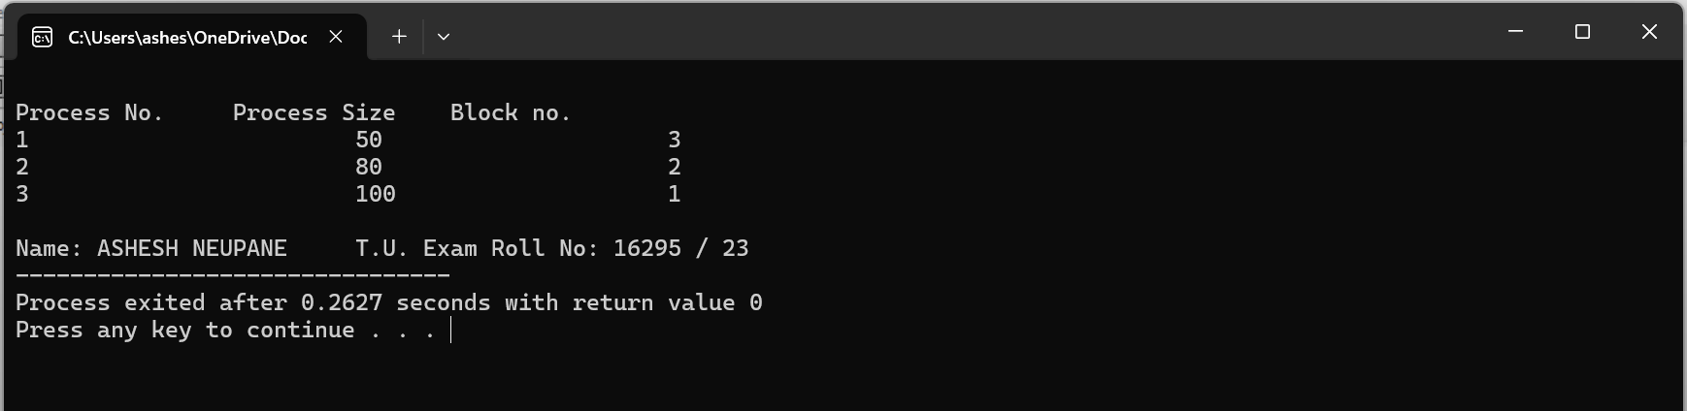

Write a C program to implement the Shortest Remaining Time First (SRTF) Algorithm.
Source Code:
#include <stdio.h>
int main()
{
int a[10],b[10],x[10],i,j,smallest,count=0,time,n;
double avg=0,tt=0,end;
printf("enter the number of Processes:\n");
scanf("%d",&n);
printf("enter arrival time\n");
for(i=0;i<n;i++)
scanf("%d",&a[i]);
printf("enter burst time\n");
for(i=0;i<n;i++)
scanf("%d",&b[i]);
for(i=0;i<n;i++)
x[i]=b[i];

b[9]=9999;

for(time=0;count!=n;time++)
{
smallest=9;
for(i=0;i<n;i++)
{
if(a[i]<=time && b[i]<b[smallest] && b[i]>0 )
smallest=i;
}
b[smallest]--;
if(b[smallest]==0)
{
count++;
end=time+1;
avg=avg+end-a[smallest]-x[smallest];
tt= tt+end-a[smallest];
}
}
printf("\n\nAverage waiting time = %lf\n",avg/n);
printf("Average Turnaround time = %lf",tt/n);
printf("\nName: ASHESH NEUPANE \t T.U. Exam Roll No: 16295 / 23");
return 0;
}

Output Screen:
