- Write a color code table of T568B RJ45 connection.

Pin Number | Color Code | Signal | Description
1 | White/Orange | Transmit + (Tx +) | Transmits data
2 | Orange | Transmit - (Tx -) | Transmits data
3 | White/Green | Receive + (Rx +) | Receives data
4 | Blue | Unused/PoE | Used for Power over Ethernet (PoE)
5 | White/Blue | Unused/PoE | Used for Power over Ethernet (PoE)
6 | Green | Receive - (Rx -) | Receives data
7 | White/Brown | Unused/PoE | Used for Power over Ethernet (PoE)
8 | Brown | Unused/PoE | Used for Power over Ethernet (PoE)

- Suppose you are a network administrator of Shankerdev Campus. You need to create two VLAN Named IT and Finance that are connected to a single switch which is then connected to a single router for inter-vlan routing. Connect two computers in each VLAN and make sure computers in different VLAN can communicate with each other. The IP address in all the computers should be assigned dynamically using DHCP protocol. The network subnets are:
Device Name | IP Address | Subnet | Gateway
PC 0 (switch 1) | 192.168.9.2 | /24 | 192.168.9.254
PC 1 (switch 1) | 192.168.9.3 | /24 | 192.168.9.254
PC 2 (switch 2) | 10.101.9.2 | /24 | 10.101.9.254
PC 3 (switch 2) | 10.101.9.3 | /24 | 10.101.9.254

Output:
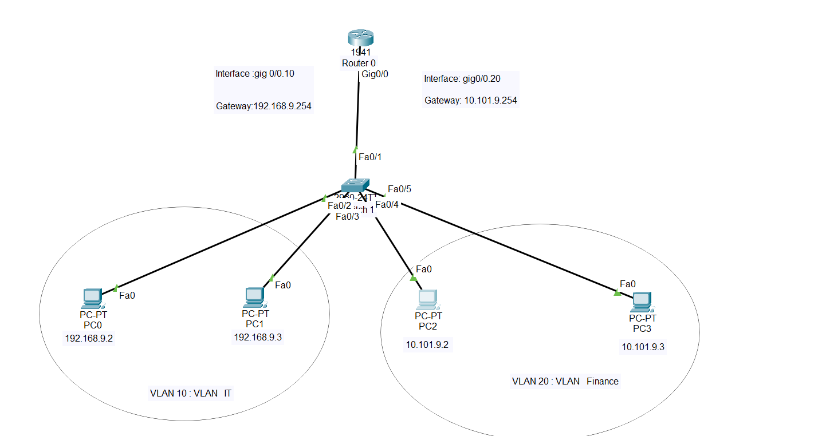

- Detailed information of how I did:
In this task, I used four computers, a switch, and a router. The switch is directly connected to all four computers, and each PC is assigned a unique IP address configured dynamically using the DHCP protocol.
In the switch configuration, two VLANs were created: VLAN 10 and VLAN 20. VLAN 10 was named IT VLAN, and VLAN 20 was named Finance VLAN. The IT VLAN was assigned to interfaces Fa0/2 and Fa0/3, while the Finance VLAN was assigned to interfaces Fa0/4 and Fa0/5. The switch is also directly connected to the router through interface Fa0/1.
Using the command prompt on PC0, I attempted to ping PC3. The ping was unsuccessful because both computers belong to different VLANs, and communication between different VLANs is not possible without inter-VLAN routing.
To enable inter-VLAN routing, the router was configured accordingly. The physical interface Gig0/0 of the router was virtually divided into two sub-interfaces: Gig0/0.10 and Gig0/0.20. Each sub-interface was assigned an appropriate encapsulation type along with a gateway IP address and subnet mask.
After completing the router configuration, the ping between PC0 and PC3 became successful as shown in the picture below:
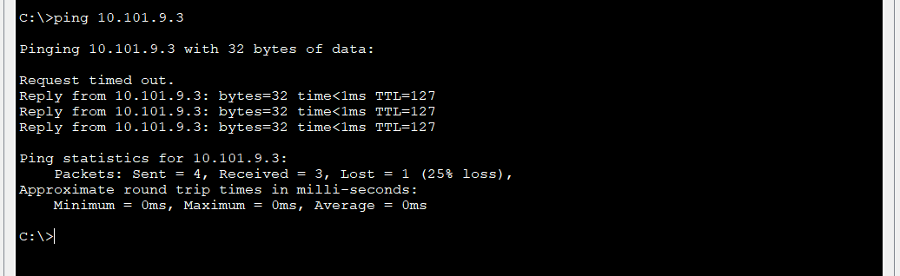

- Screenshot of Desktop IP configuration:
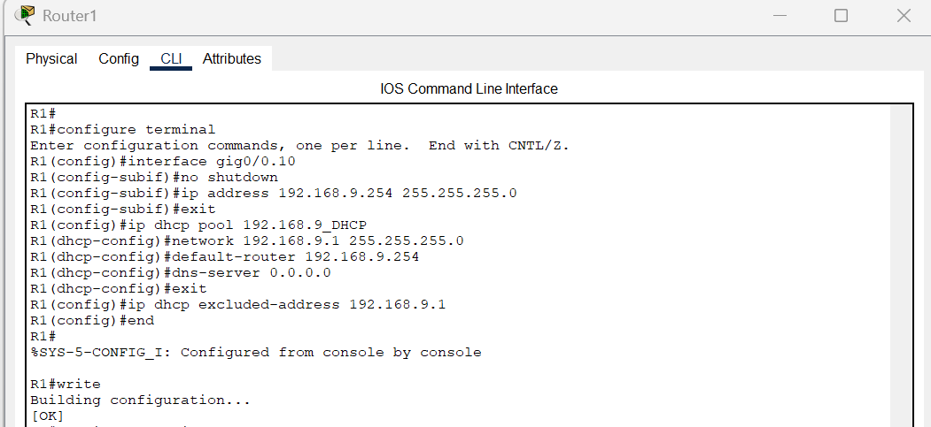

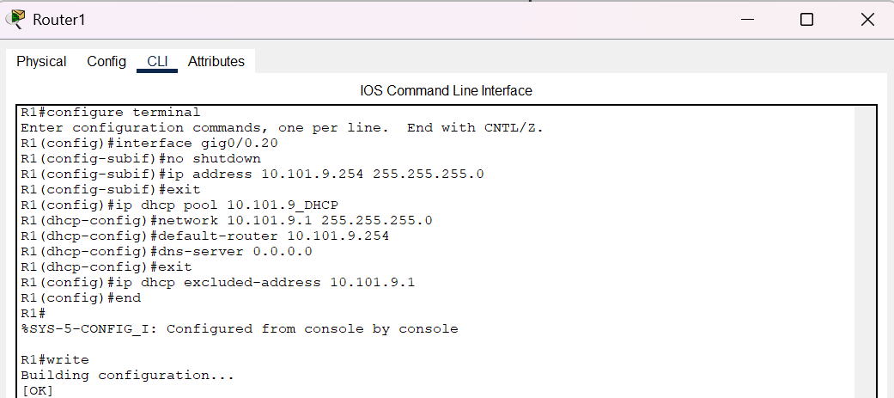

- PC 0:
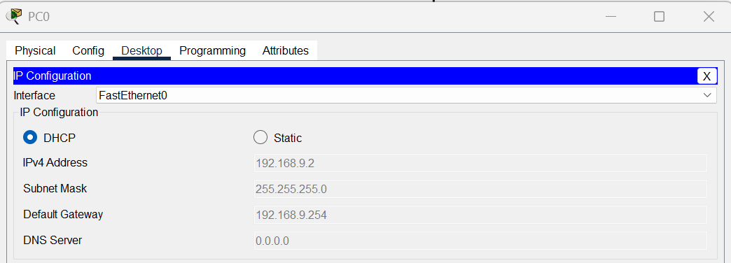
- PC 1:
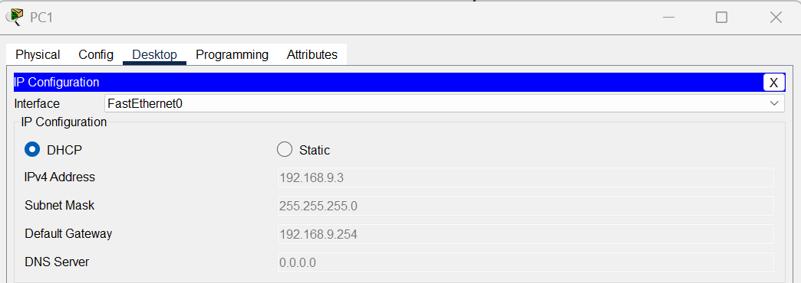
- PC 2:
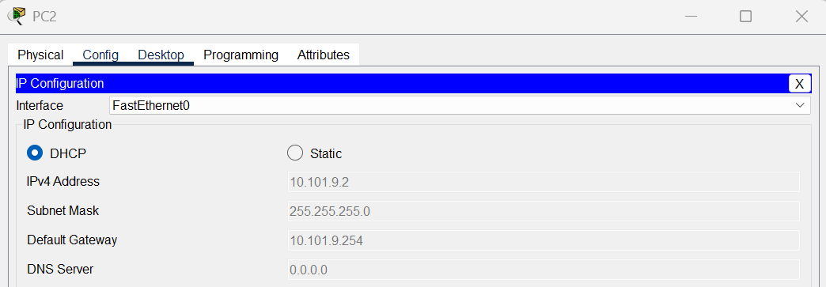

- PC 3:
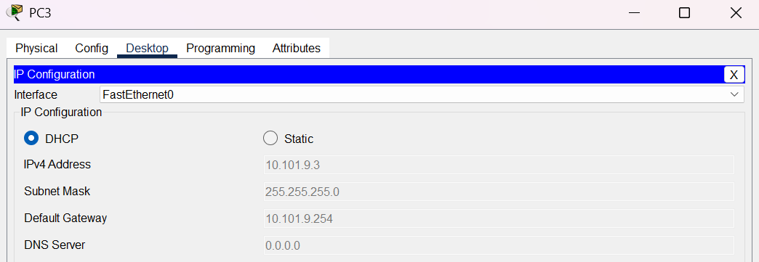
- Screenshot of DHCP pool information:
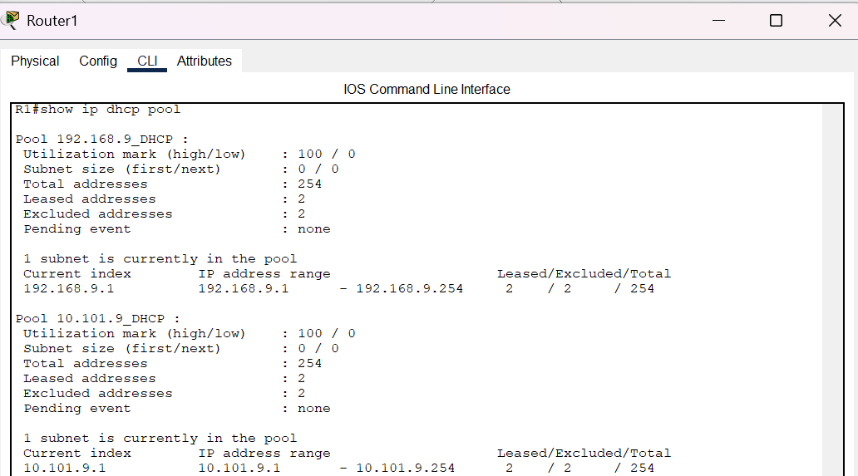

- Screenshot of VLAN Configuration:
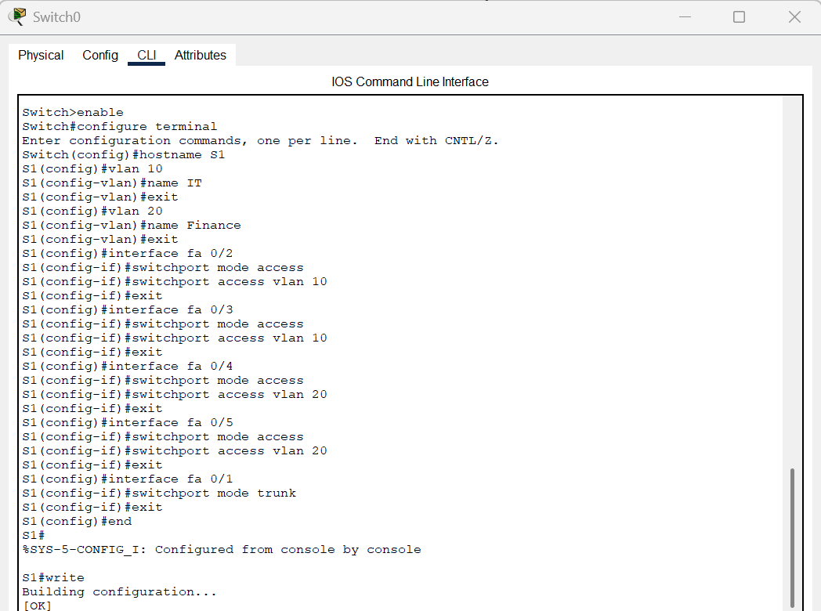
To verify the above switch configuration, the IT VLAN should be assigned to interfaces Fa0/2 and Fa0/3, while the Finance VLAN should be assigned to interfaces Fa0/4 and Fa0/5, as clearly shown in the figure below.
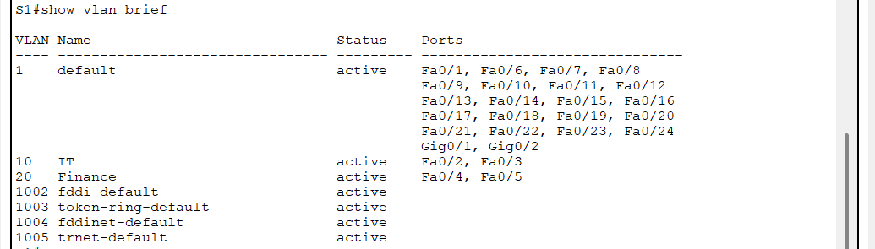

- Screenshot of Router IP Configuration:
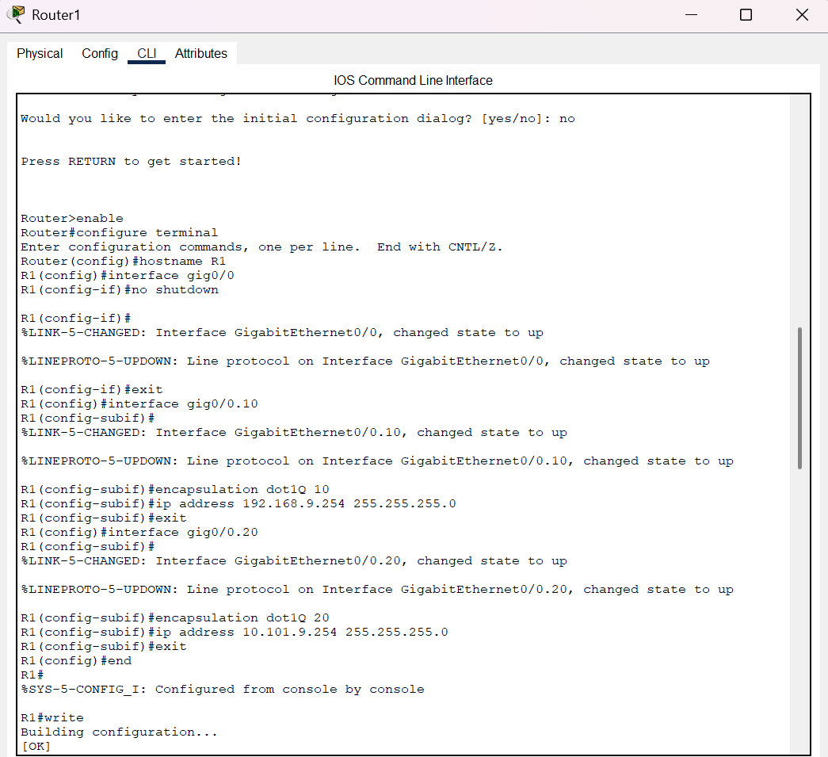
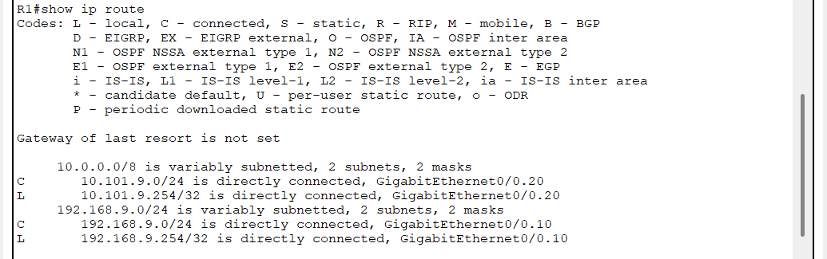

- Ping failure before configuration and success after configuration between PC0 and PC3:
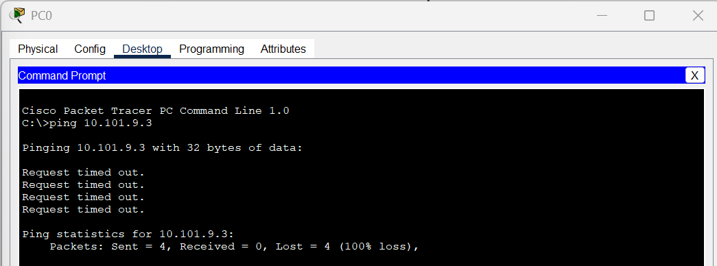
After the Inter-VLAN Routing is configured correctly, devices in different VLANs can communicate with each other, as shown in the figure below.

- You are a network administrator of ShankerDev Campus. You are responsible for designing a simple network by connecting two routers in Block A and Block B where each router is connected to one switch in which two desktops are connected respectively. Configure a static route to connect Block A desktop and Block B desktop. The network information should be:
Device Name | IP Address | Subnet | Gateway
PC 0 (switch 1) | 192.168.9.2 | /24 | 192.168.9.254
PC 1 (switch 1) | 192.168.9.3 | /24 | 192.168.9.254
PC 2 (switch 2) | 10.10.9.2 | /24 | 10.10.9.254
PC 3 (switch 2) | 10.10.9.3 | /24 | 10.10.9.254

Output:

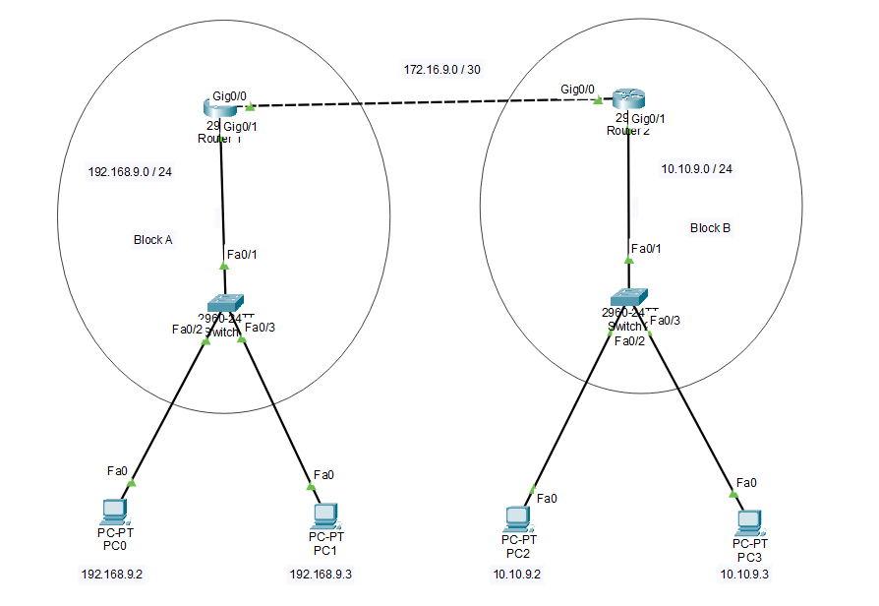

- Detail information of how I did:
In this task, I connected two separate network blocks (Block A and Block B) at ShankerDev Campus by designing a simple network topology. Each block contains a router connected to a switch, with two desktop PCs connected to each switch. Appropriate IP addresses were assigned to each desktop, switch, and router interface to ensure that they belong to different subnets.
In Block A, desktops PC0 and PC1 were assigned IP addresses within the 192.168.9.0/24 subnet, while in Block B, desktops PC2 and PC3 used the 10.10.9.0/24 subnet. The routers were connected via their serial interfaces using a point-to-point link with the subnet 172.16.9.0/30.
Static routing was configured on both routers to enable communication between the two LANs. On Router A, a static route was added to reach the 10.10.9.0/24 network via the next-hop IP address of Router B. Similarly, on Router B, a static route was configured to reach the 192.168.9.0/24 network via Router A’s serial interface IP.
Before configuring routing, a ping test from PC0 (Block A) to PC3 (Block B) failed, indicating that there was no route between the networks. After static routing was properly configured, the ping was successful, confirming that the routing tables were correctly updated and the two networks were fully connected.
- Screenshot of Desktop IP configuration:
- PC 0:
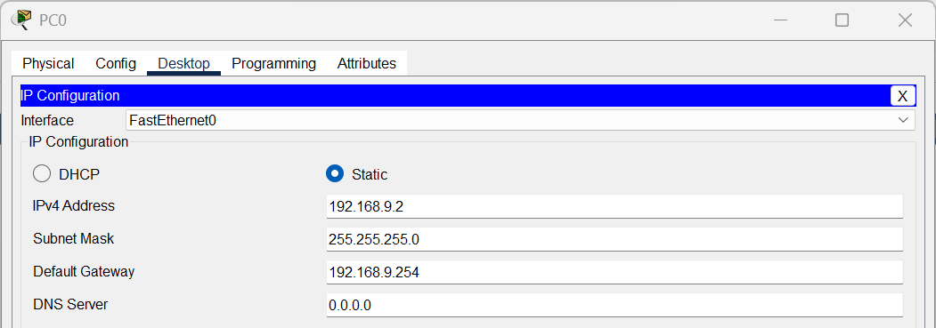

- PC 1:
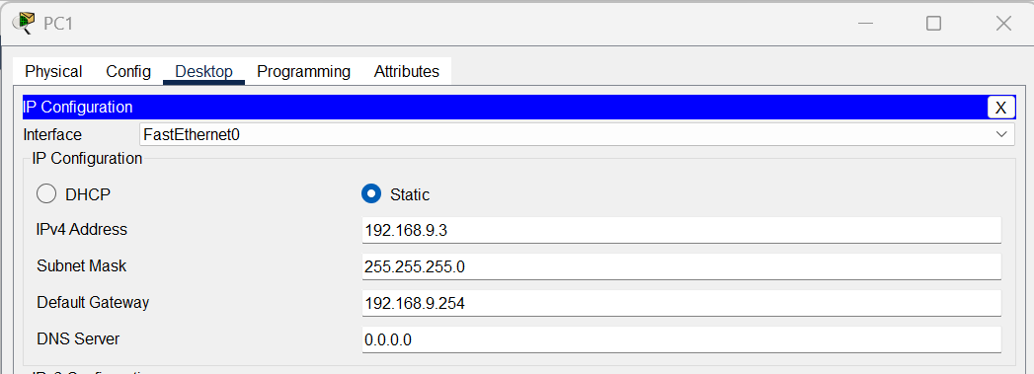
- PC 2:
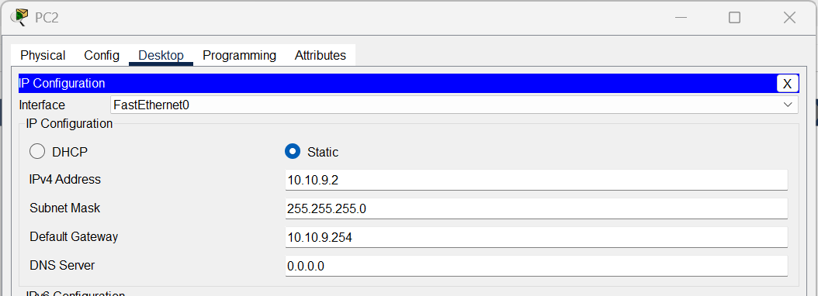
- PC 3:
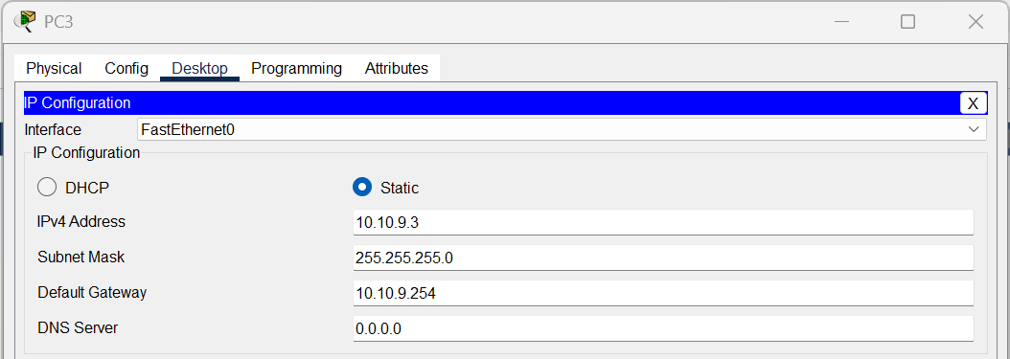

- Screenshot of Router IP Configuration:
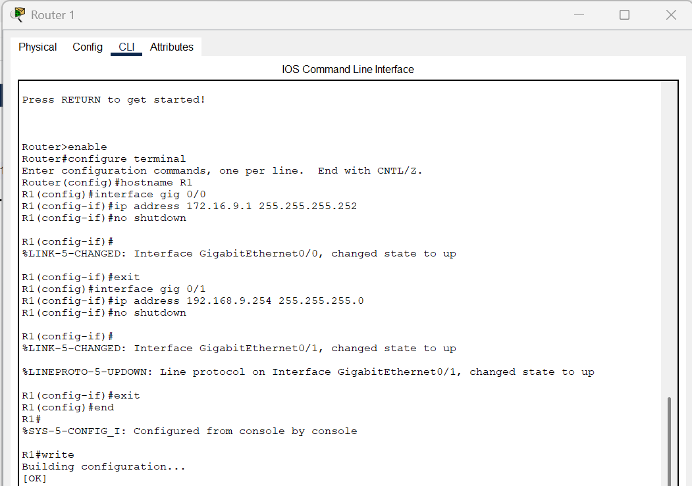
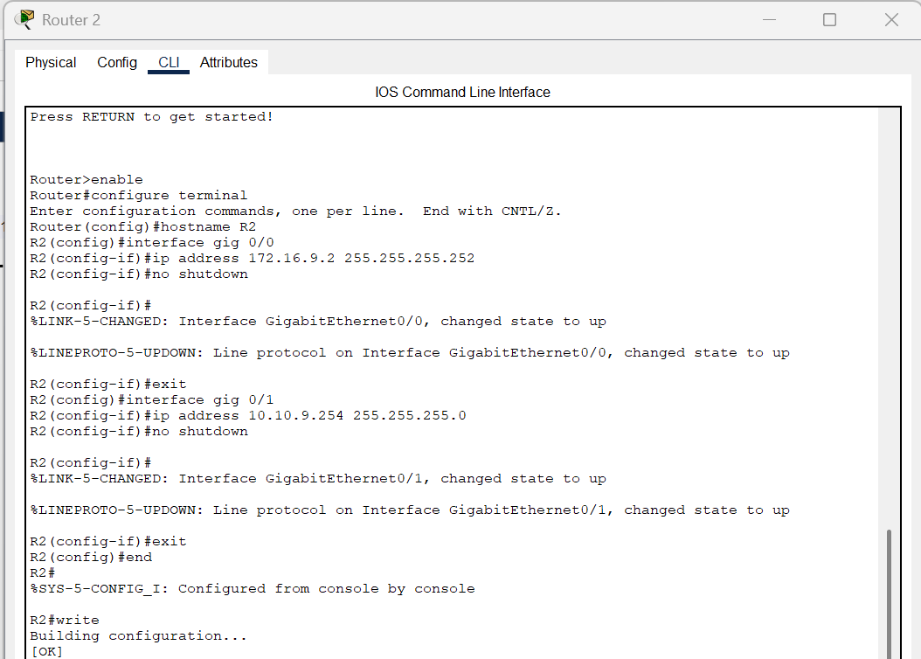
- Screenshot of static routing:
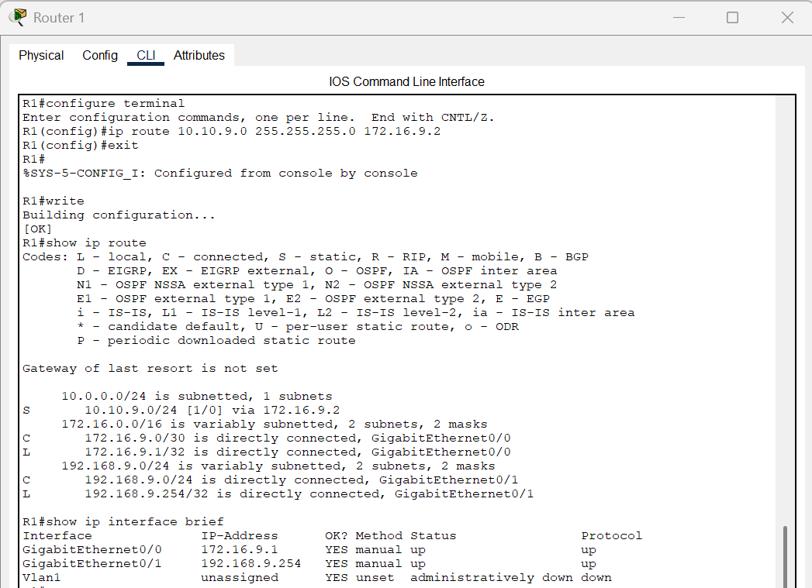

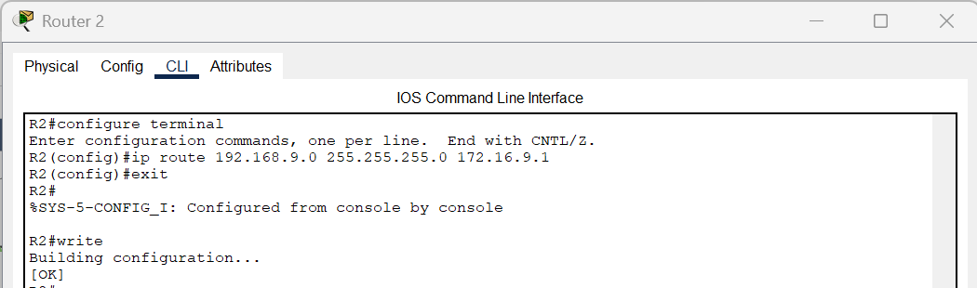

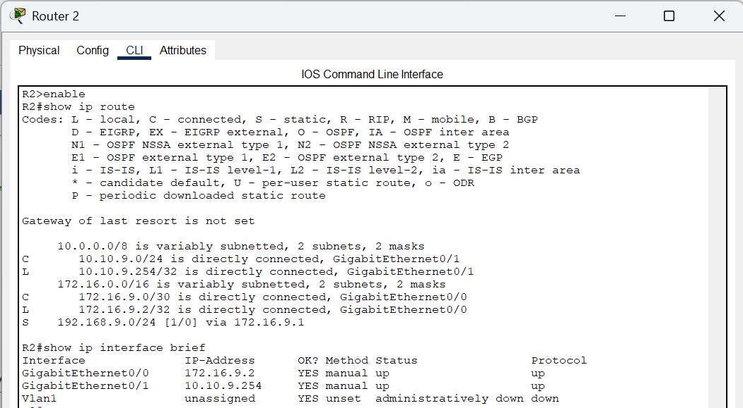

- Ping failure before configuration and success after configuration between PC0 and PC3:
Before configuring static routing, I tested the connectivity between PC0 in Block A and PC3 in Block B. However, the ping from PC0 to PC3 failed, displaying a “Request timed out” message. This occurred because the routers in each block were unaware of each other’s networks, and no route existed to forward packets between them.
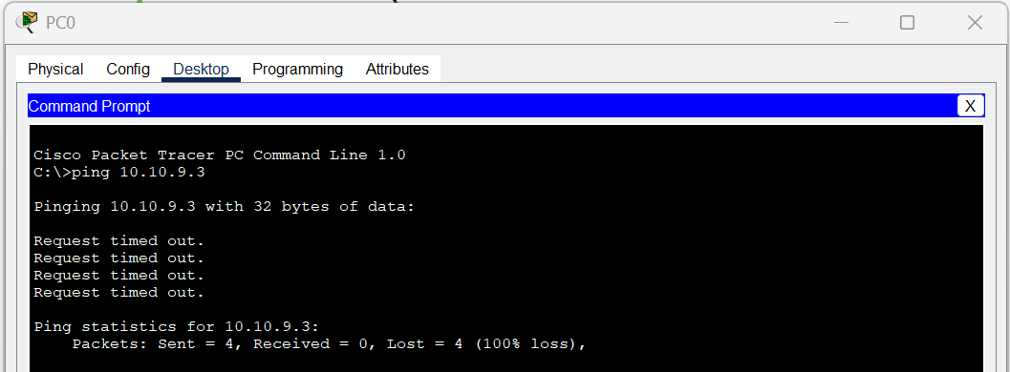

After configuring static routing, I repeated the ping test from PC0 to PC3. This time, the ping was successful, confirming that static routing had enabled proper communication between the two networks, as shown in the figure below.
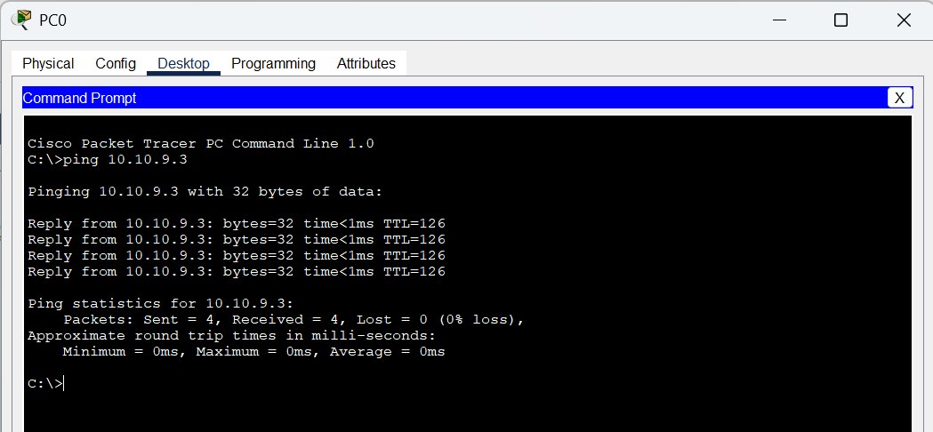

- Consider you are a network engineer and need to design a network design where three routers (Router 2911), namely R1, R2 and R3 are interconnected with each other directly and within each router one switch is connected and within that switch, two personal computers are connected. Configure OSPF dynamic routing to connect each network. The IP information is:
Device Name | IP Address | Subnet | Gateway
PC 0 (Switch 1) | 192.168.9.2 | /24 | 192.168.9.254
PC 1 (Switch 1) | 192.168.9.3 | /24 | 192.168.9.254
PC 2 (Switch 2) | 10.10.9.2 | /24 | 10.10.9.254
PC 3 (Switch 2) | 10.10.9.3 | /24 | 10.10.9.254
PC 4 (Switch 3) | 10.100.9.2 | /24 | 10.100.9.254
PC 5 (Switch 3) | 10.100.9.3 | /24 | 10.100.9.254

Output:
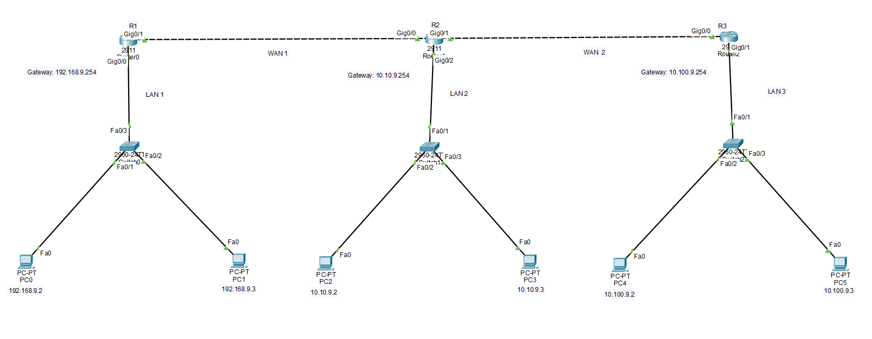

- Detail information about how I did:
In this task, I designed a network topology consisting of three Cisco 2911 routers: R1, R2, and R3, each directly connected to one another. Each router was also connected to a switch, and each switch had two PCs connected to it. Appropriate IP addresses and subnet masks were assigned to all PCs based on the provided information. The default gateways on the PCs were configured to match their respective router interfaces: 192.168.9.254 for PC0 and PC1 (R1), 10.10.9.254 for PC2 and PC3 (R2), and 10.100.9.254 for PC4 and PC5 (R3).
Initially, when I attempted to ping between PCs on different networks such as from PC0 to PC3 and from PC0 to PC5 -the ping requests failed, indicating that routing had not yet been configured.
To enable communication across all networks, I configured OSPF (Open Shortest Path First) dynamic routing on all three routers. A unique router ID was assigned to each router, and OSPF process ID 1 was used. Network statements were added for all connected subnets, and OSPF was activated on the interfaces connected to other routers and LANs.
After enabling OSPF, I verified the routing tables on each router and confirmed that all routes were successfully learned dynamically through OSPF. Following the routing setup, I reattempted the ping tests between PCs across different networks. This time, all pings were successful from PC0 to PC3, PC0 to PC5, and vice versa - confirming that OSPF dynamic routing was functioning correctly.
- Screenshot of Desktop IP Configuration:
- PC 0:
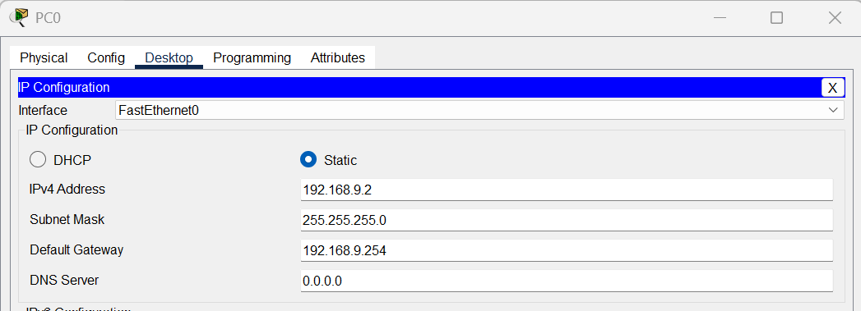

- PC 1:
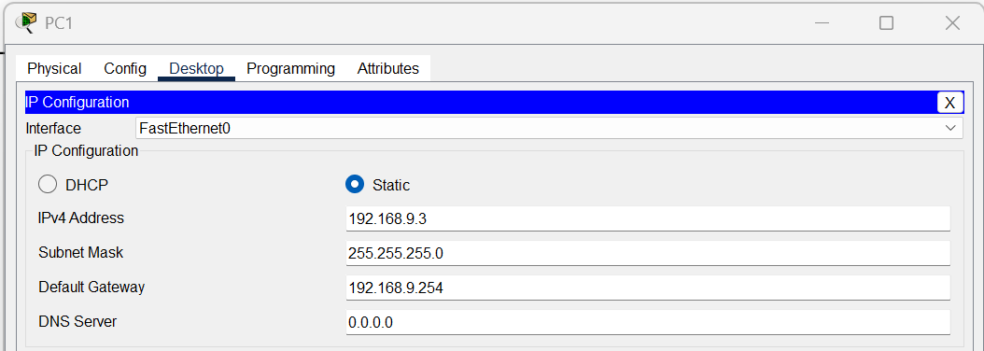
- PC 2:
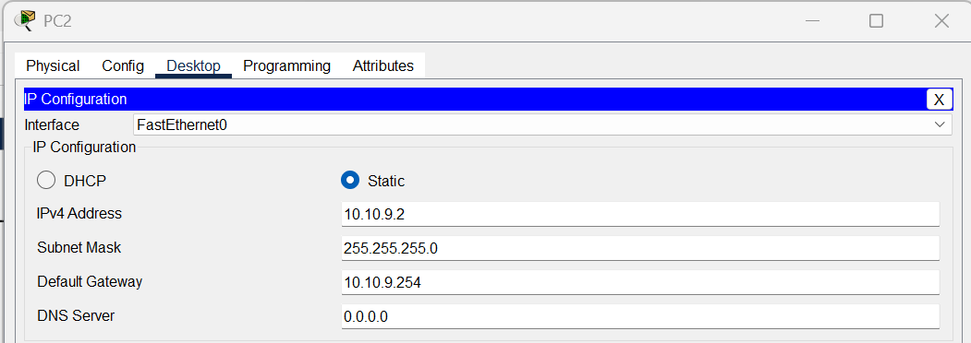
- PC 3:
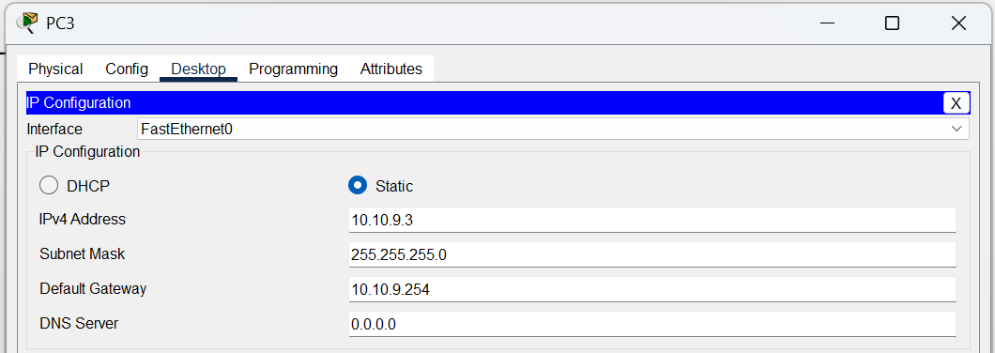

- PC 4:
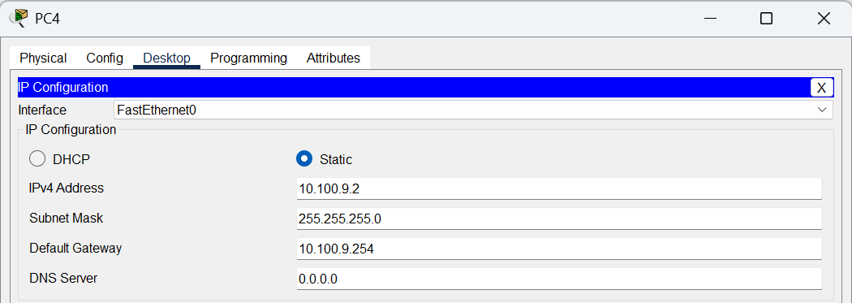
- PC 5:
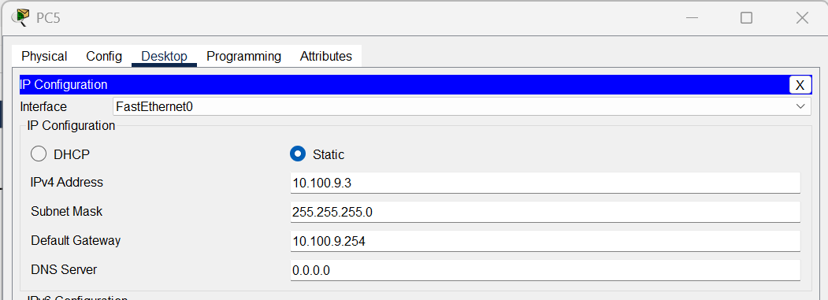
- Screenshot of Router IP Configuration:
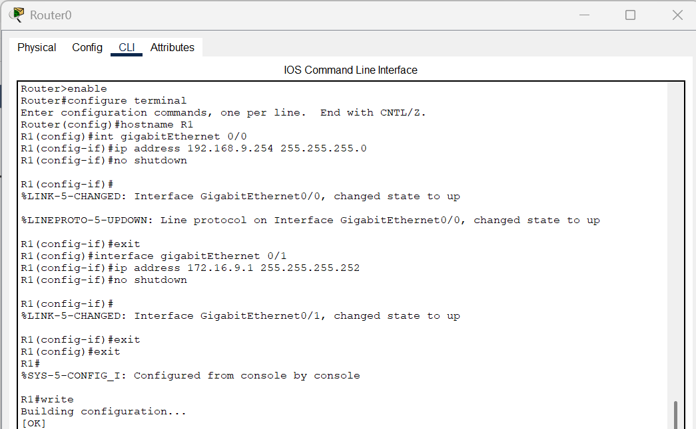
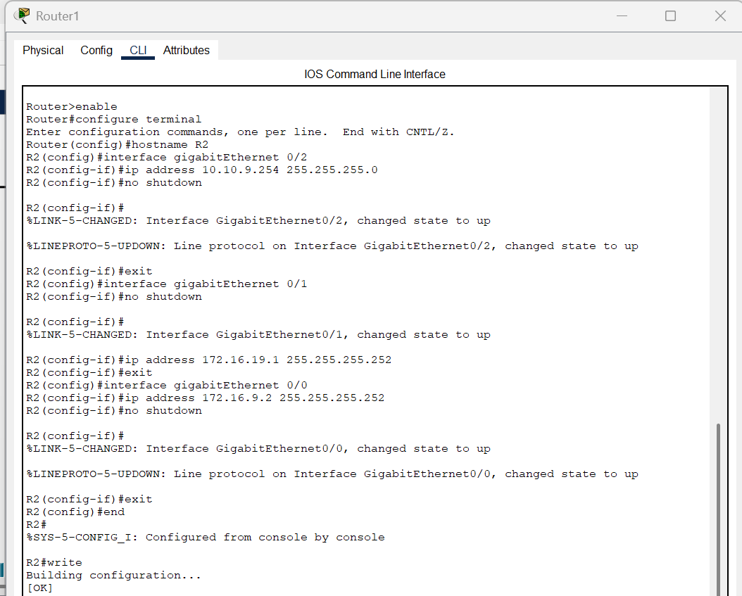
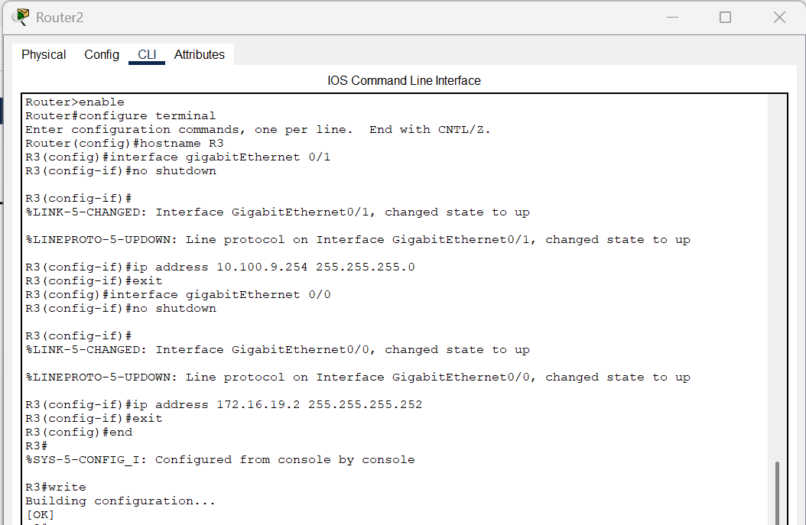
- Screenshot of OSPF routing of each router:
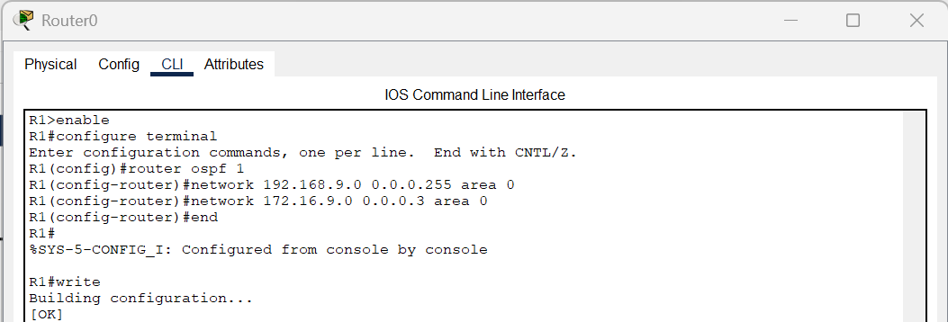
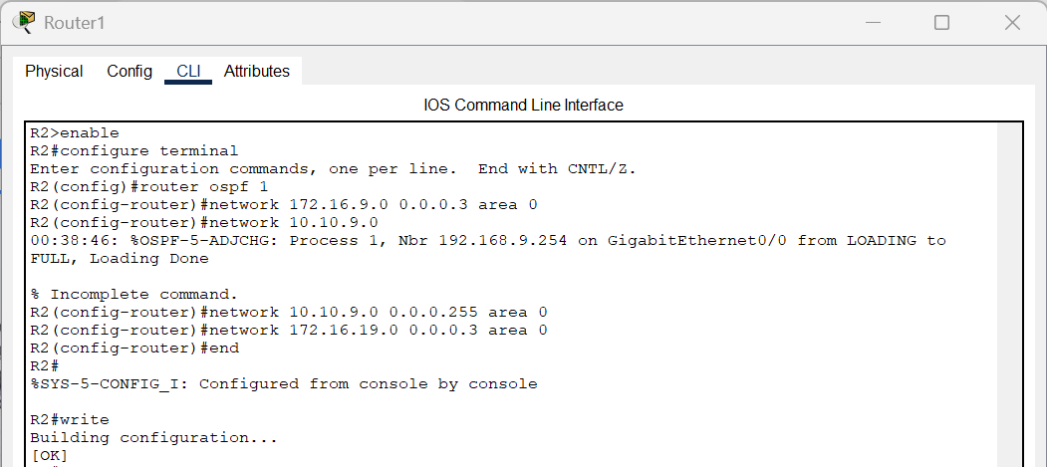
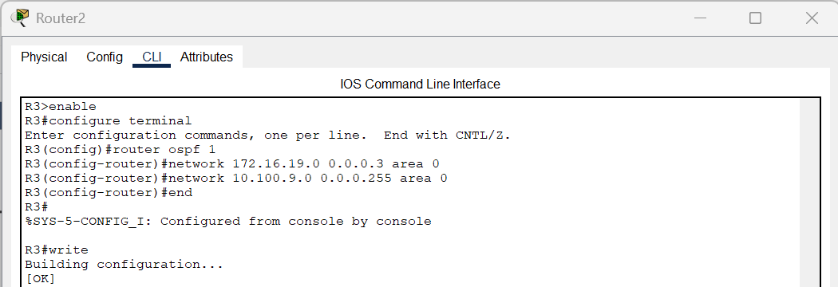

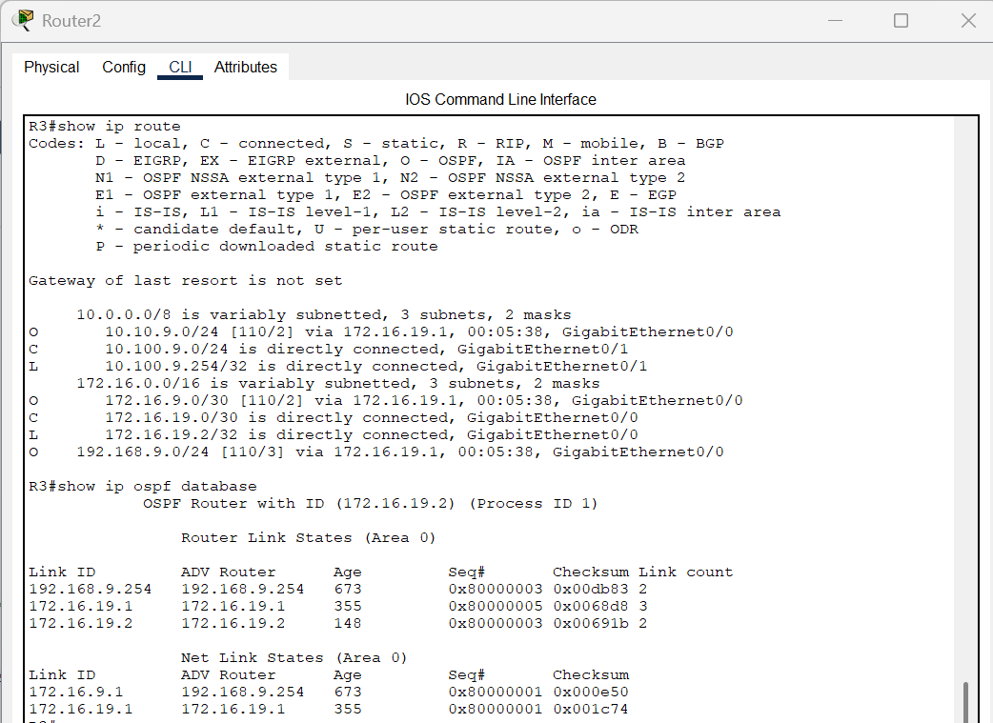

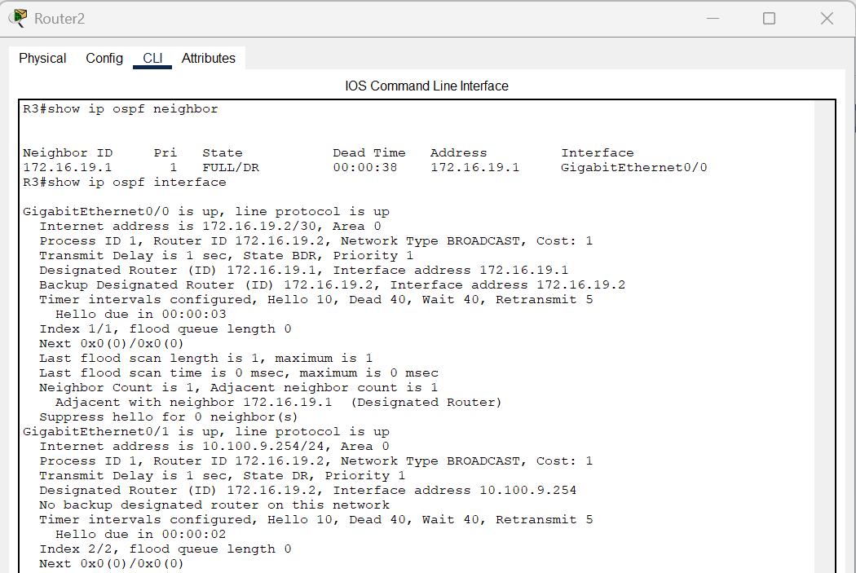

- Ping failure before configuration and success after configuration between PC0 and PC3, PC0 and PC5 and vice - versa.

When pinging between PCs across different networks such as from PC0 to PC3, PC0 to PC5, PC3 to PC0, and PC5 to PC0 the ping requests failed, indicating that OSPF dynamic routing had not yet been configured, as shown in the figure below.

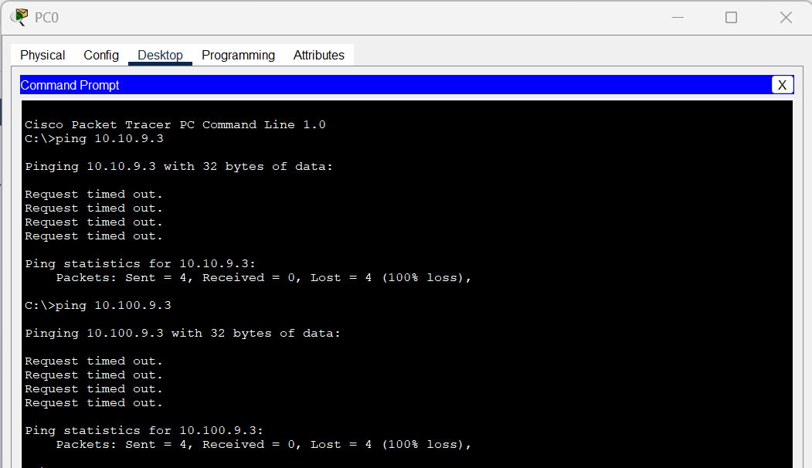

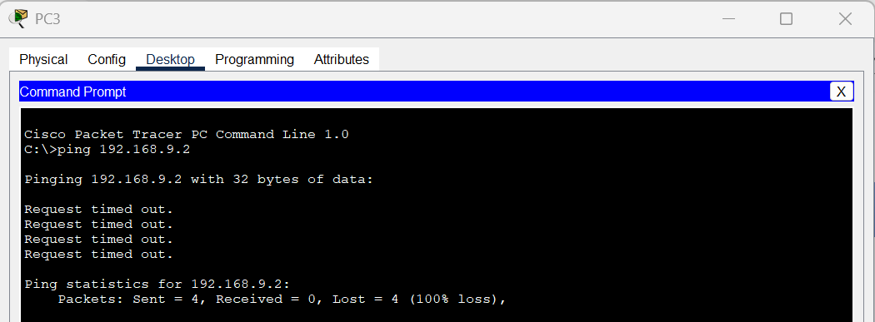

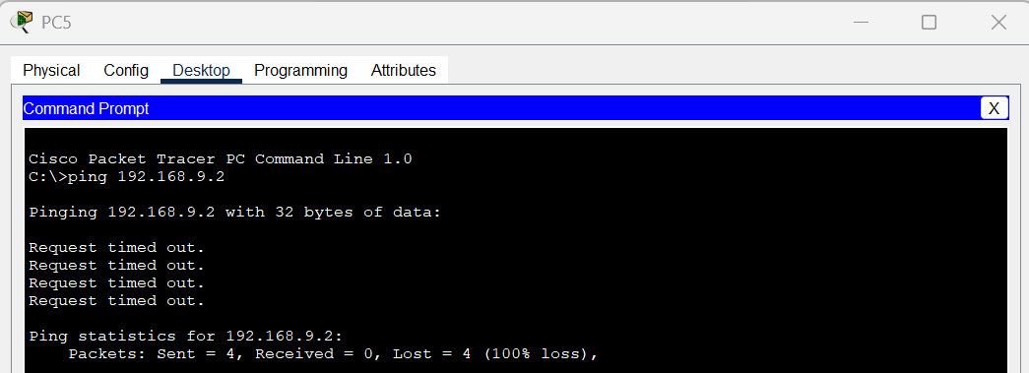

After configuring OSPF dynamic routing on all three routers, pinging between PCs across different networks such as from PC0 to PC3, PC0 to PC5, PC3 to PC0, and PC5 to PC0 became successful, as shown in the figure below.

