A Weekly Report
On The Business Transactions Of
Honors & Co.

Global College of Management
Baneshwor, Kathmandu

Submitted By
SURAJ CHAUDHARY
Class: XI ‘B’
Shift: Day

Submitted To
Mr. Rajesh Bhandari
Faculty of Department of Accountancy

January 21, 2022
Table of Contents
Introduction 3
Transactions 4
Journal Entries 5
Ledger Accounts 6
Trial Balance 9
Attached 10

Introduction

Honors & Co. is a group of stationery shops spread across Nepal. They are known for their quality products which are often imported from other countries. They have a vast network of suppliers and buyers. They not only sell the products directly to the customers, but they also supply them to other businesses and stationery.

Honors & Co. was founded in 2019 AD as a partnership project by a group of students from Global College of Management. With the funding received from the management members of Global College of Management itself, the company (Honors & Co.) have been supplying stationery materials throughout the country.

This report comprises of the weekly report on the business transactions of Honors & Co. It consists of the journal entries, ledger accounts and trial balance of the organization.

Transactions

Here are the transactions of Honors & Co. for a week.

  - Started a business with cash Rs 5,00,000 and bank balance Rs 3,00,000
  - Purchased 6 vehicles for Rs 3,00,000.
  - Received Rs 2,00,000 in full settlement of 2,10,000 from Ramesh.
  - Purchased 50 Accountancy books for Rs 200 each, and 30 Mathematics book for Rs 250 each.
  - Cash withdrawn from bank Rs 50,000 for personal use.
  - Paid Rs 2,00,000 for rent.
  - Paid Rs 50,000 from Dot Focus Stationery in full settlement of 60,000.

Journal Entries

Journal Entries
In the books of Honors & Co.

Date | Particulars | LF | Dr. Amount | Cr. Amount
1-1 | Cash a/c  Bank a/c  To Capital a/c  (Being business started with cash and bank balance) |  | 5,00,000  3,00,000 | 8,00,000
1-2 | Vehicle a/c  To Cash a/c  (Being vehicles purchased) |  | 3,00,000 | 3,00,000
1-3 | Cash a/c  Discount a/c  To Ramesh a/c  (Being cash received from Ramesh in full settlement) |  | 2,00,000  10,000 | 2,10,000
1-4 | Purchase a/c  To Cash a/c  (Being Accountancy and Mathematics books purchased) |  | 17,500 | 17,500
1-5 | Drawing a/c  To Bank a/c  (Being cash withdrawn from bank for personal use) |  | 50,000 | 50,000
1-6 | Rent a/c  To Cash a/c  (Being paid for rent) |  | 2,00,000 | 2,00,000
1-7 | Dot Focus Stationery a/c  To Cash a/c  To Discount a/c  (Being cash paid in full settlement) |  | 60,000 | 50,000  10,000
 | Total |  | 16,37,500 | 16,37,500

Ledger Accounts

Cash a/c

Date | Particulars | JF | Dr. Amount | Cr.  Amount | Dr./  Cr. | Balance
1-1 | Capital a/c |  | 5,00,000 | - | Dr. | 5,00,000
1-2 | Vehicle a/c |  | - | 3,00,000 | Dr. | 2,00,000
1-3 | Ramesh a/c |  | 2,00,000 | - | Dr. | 4,00,000
1-4 | Purchase a/c |  | - | 17,500 | Dr. | 3,82,500
1-6 | Rent a/c |  | - | 2,00,000 | Dr. | 1,82,500
1-7 | Dot Focus Stationery a/c |  | - | 50,000 | Dr. | 1,32,500

Bank a/c

Date | Particulars | JF | Dr. Amount | Cr.  Amount | Dr./  Cr. | Balance
1-1 | Capital a/c |  | 3,00,000 | - | Dr. | 3,00,000
1-5 | Drawing a/c |  | - | 50,000 | Dr. | 2,50,000

Capital a/c

Date | Particulars | JF | Dr. Amount | Cr.  Amount | Dr./  Cr. | Balance
1-1 | Cash a/c |  | - | 5,00,000 | Cr. | 5,00,000
1-1 | Bank a/c |  | - | 3,00,000 | Cr. | 8,00,000

Vehicle a/c

Date | Particulars | JF | Dr. Amount | Cr.  Amount | Dr./  Cr. | Balance
1-2 | Cash a/c |  | 3,00,000 | - | Dr. | 3,00,000

Discount a/c

Date | Particulars | JF | Dr. Amount | Cr.  Amount | Dr./  Cr. | Balance
1-3 | Ramesh a/c |  | 10,000 | - | Dr. | 10,000
1-7 | Dot Focus Stationery a/c |  | - | 10,000 | - | Nil

Ramesh a/c

Date | Particulars | JF | Dr. Amount | Cr.  Amount | Dr./  Cr. | Balance
1-3 | Cash and Discount a/c |  | - | 2,10,000 | Cr. | 2,10,000

Purchase a/c

Date | Particulars | JF | Dr. Amount | Cr.  Amount | Dr./  Cr. | Balance
1-4 | Cash a/c |  | 17,500 | - | Dr. | 17,500

Drawing a/c

Date | Particulars | JF | Dr. Amount | Cr.  Amount | Dr./  Cr. | Balance
1-5 | Bank a/c |  | 50,000 | - | Dr. | 50,000

Rent a/c

Date | Particulars | JF | Dr. Amount | Cr.  Amount | Dr./  Cr. | Balance
1-6 | Cash a/c |  | 200,000 | - | Dr. | 200,000

Dot Focus Stationery a/c

Date | Particulars | JF | Dr. Amount | Cr.  Amount | Dr./  Cr. | Balance
1-7 | Cash and Discount a/c |  | 60,000 | - | Dr. | 60,000

Trial Balance

Trial Balance of Honors & Co.
As on January 7, 2020

S. N. | Particulars | JF | Dr. Amount | Cr.  Amount
1. | Cash a/c |  | 1,32,500 | -
2. | Bank a/c |  | 2,50,000 | -
3. | Capital a/c |  | - | 8,00,000
4. | Vehicle a/c |  | 3,00,000 | -
5. | Discount a/c |  | - | -
6. | Ramesh a/c |  | - | 2,10,000
7. | Purchase a/c |  | 17,500 | -
8. | Drawing a/c |  | 50,000 | -
9. | Rent a/c |  | 200,000 | -
10. | Dot Focus Stationery a/c |  | 60,000 | -
 | Total |  | 10,10,000 | 10,10,000

Attached

Date: 1-2
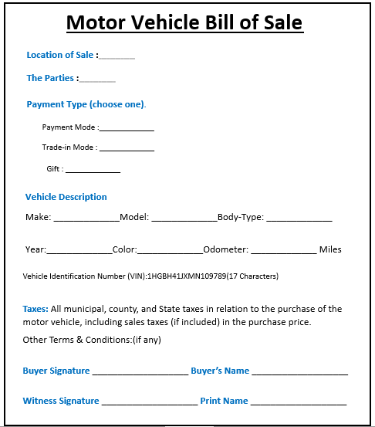
Suzuki Van 340
6
Number:
Gray
2020
Cash
Honors & Co., Alto Motors
Kathmandu

Date: 1-4
17,500
Rs 250
7,500
Mathematics Book
30
10,000
Rs 200
Accountancy Book
50
Pen & Pencil Stationery

